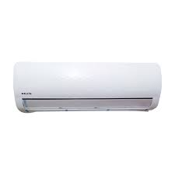

ELITE

* Smart Connectivity
* 40% Energy Saving
* 40% Energy Saving
* Super Quick-Cool
* **36,000৳**